UCAS information

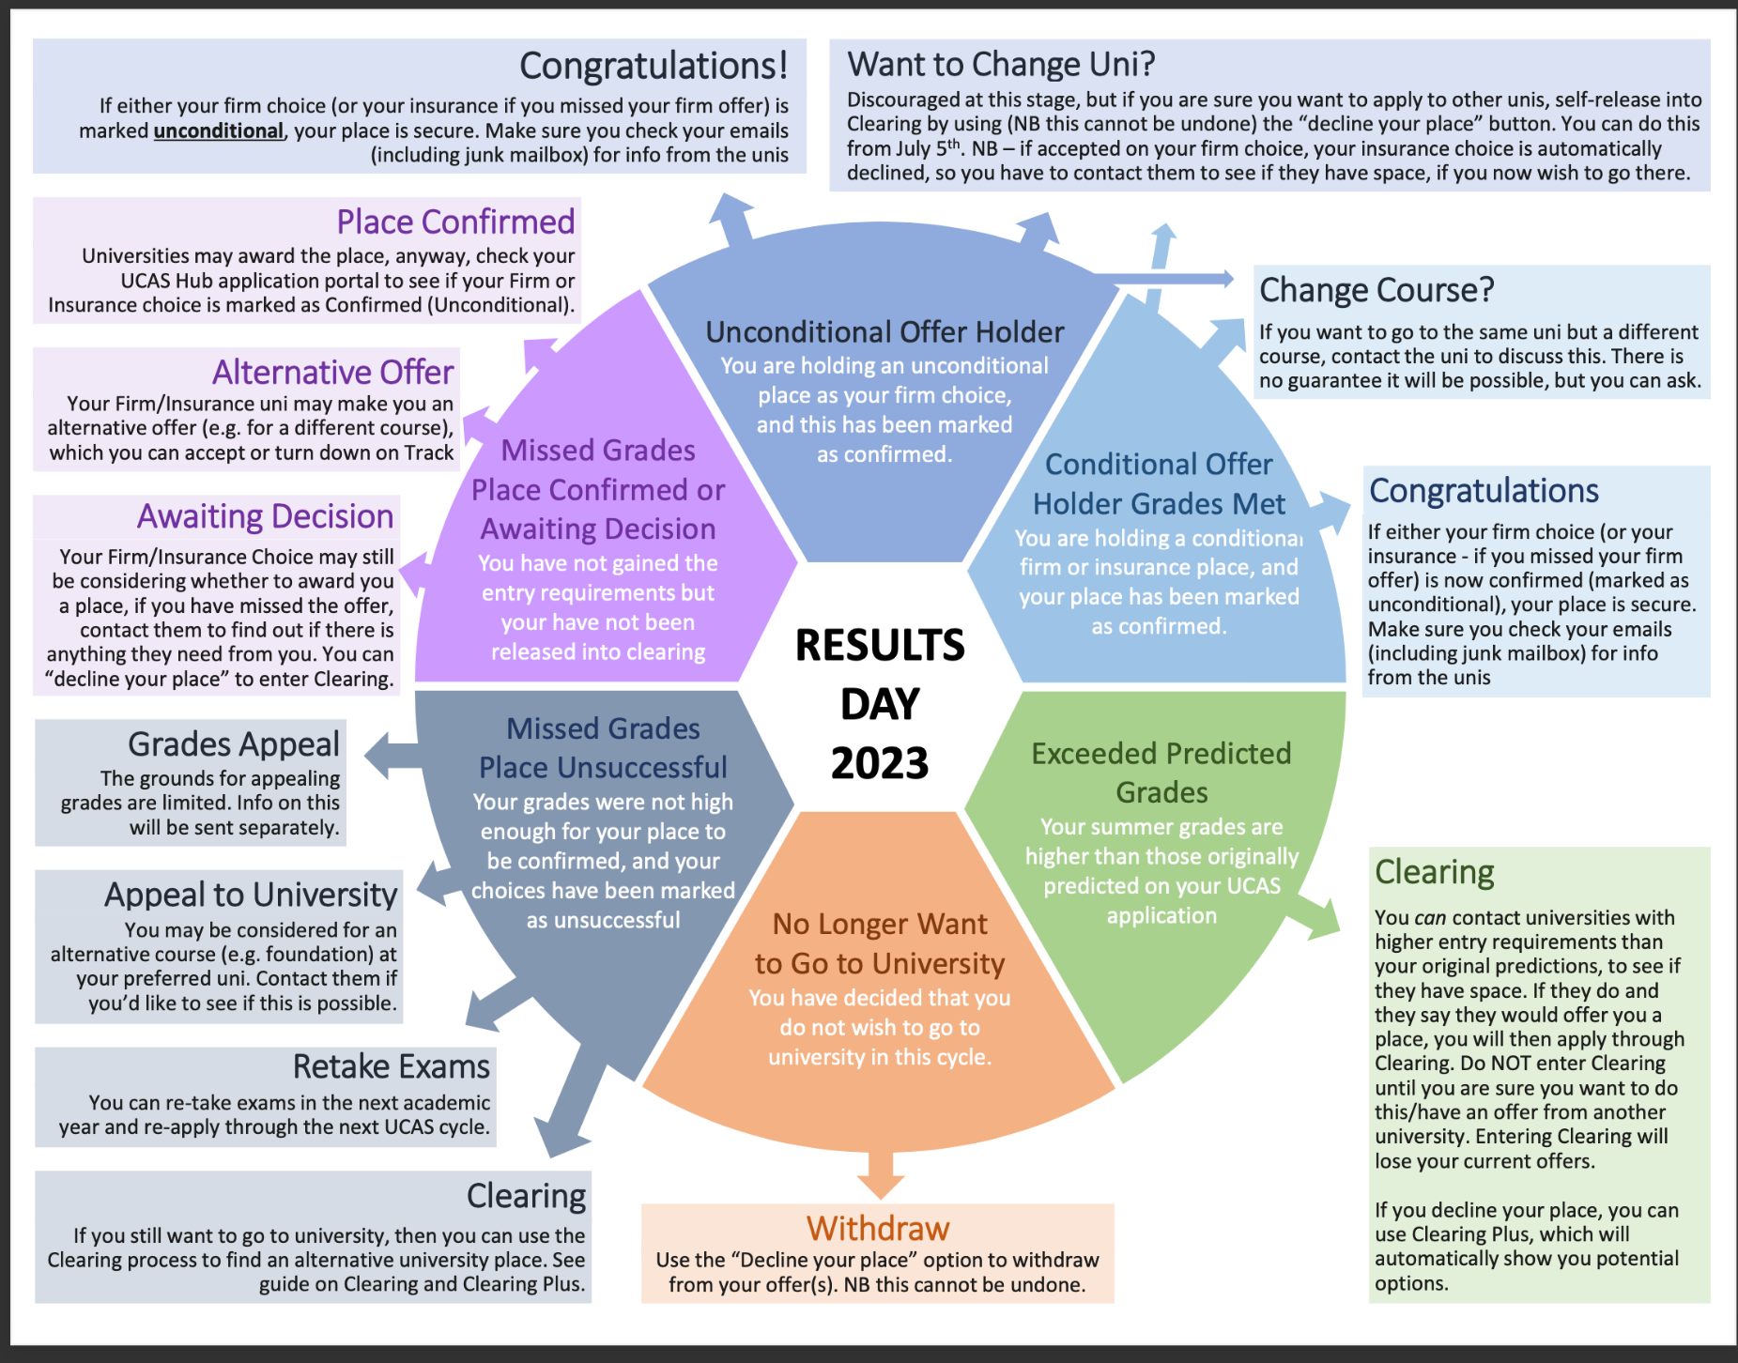
Timeline for applications

30 June at 18:00

- If you want to apply but have not yet done so, this is the final date for your application to be entered. Just get in touch if you intend to apply and I will support your application.

- UCAS Undergraduate applications received after 30 June are entered into Clearing.

4 July

- Last day for applicants to add an Extra choice in their application.

5 July onwards

- Clearing opens and vacancies are displayed in our search tool. If you are unsure about your firm choice this is when you can try to change that. Just let me know if you need support.

- Clearing numbers automatically show in applications for eligible applicants.

- Applicants holding a place can use the ‘Decline my place’ button in their application.

31 July at 18:00 – 17 August at 09:00

Results embargo – during this time:
- applications will not be updated
- adviser portal will not be updated
- universities and colleges cannot discuss any applicants’ individual status with them, or with an adviser

17 August
Publication of AS/A Level results.

08:00:
UCAS Customer Experience Centre and social media support opens for applicants.
UCAS Hub is open and students can access their applications.

13:00: Eligible applicants can add a Clearing choice.

18:00: UCAS Customer Success Team, social media support, and Customer Experience Centre closes.

24 August

Publication of GCSE results. Applicants with outstanding GCSE results will need to send these directly to their chosen universities or colleges.

28 August at 18:00

Last date for receipt of 2023 entry UCAS Conservatoires applications.

6 September

Remaining offer conditions must be met.

Last date for applicants to use the ‘Decline my place’ button in their application.

21 September at 18:00

Last date for receipt of 2023 entry UCAS Undergraduate applications.

17 October

Last date to add Clearing choices and for unis/colleges to make decisions.

