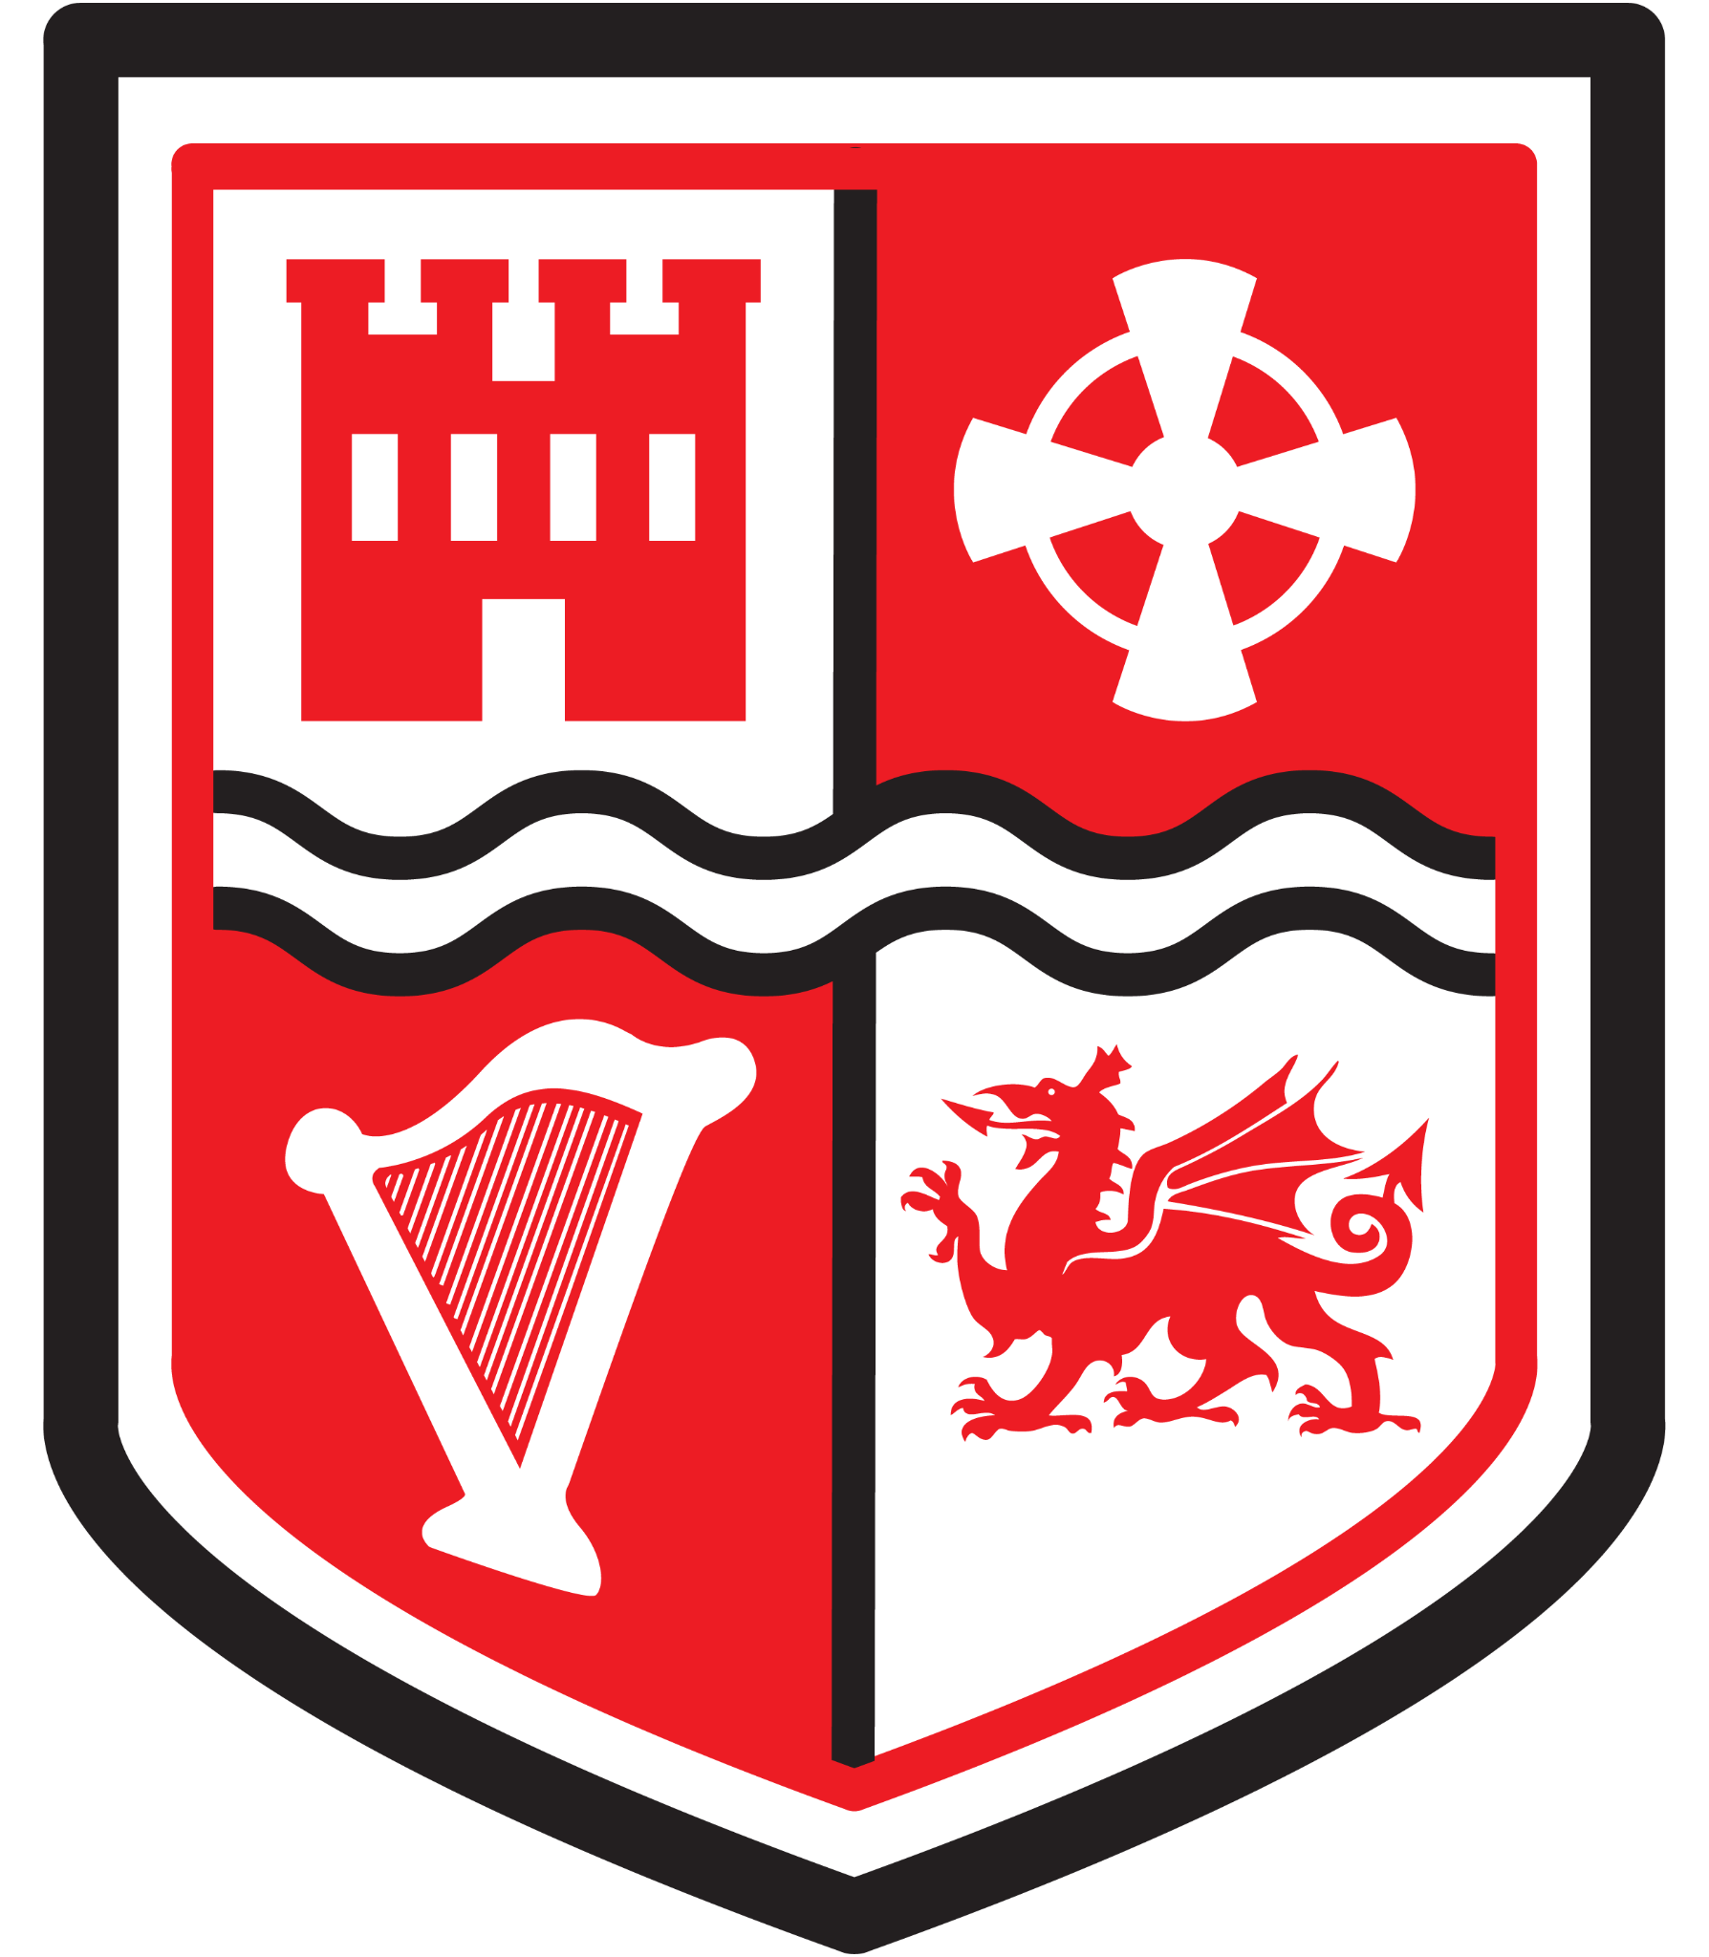

St Cyres School Uniform

The St Cyres School uniform is available to purchase from:

A Class Apart YC Sports Ruckleys
Dinas Powys CF64 4NR Cardiff CF11 9ND Barry CF63 4HB
02920 515722 02920 220246 01446 700006

The school has a policy requiring all pupils including Sixth Form to wear uniform. We look to Sixth Form pupils to provide smart role models for the rest of the year groups. The rules regarding appearance, including school clothing, have been drawn up with the safety and welfare of all pupils in mind. In St Cyres, we expect all students to wear the correct uniform and represent our school community. The Welsh Government also strongly encourages a school uniform, as they:

- provide a sense of identity, community and cohesion within the school
- support positive behaviour and school discipline
- ensure pupils dress appropriately for learning activities
- remove peer pressure to dress in particular fashions
- enable pupils of all backgrounds to share in a common identity
- assist identification of strangers on school premises
- support and promote the ethos of the school.

We therefore have a smart school uniform that is compulsory for pupils to wear at all times on the journey to and from school and during the school day.

We ask all parents who send their children to our school to support the school uniform requirements. We believe that parents have a duty to send their children to school correctly dressed and ready for their daily schoolwork. Please take time to study this document so that you do not purchase items which are unacceptable for school.

Strict sanctions will be imposed on pupils who break the rules.

We have put together the following guidance sheet, to provide further clarification to assist you when purchasing any items.

All items of clothing should be clearly marked.

GENERAL APPEARANCE

Hair and Make-up

• Hair is to be clean, neat, tidy and of conventional style.

• No unusual dye or colouring.

• No tramlines to be shaved into hair.

• Long hair worn by pupils must be tied back to avoid accidents in class and workshops.

• Headscarves, bows and headbands are only allowed in black. Should there be any doubt about the acceptability of hairstyle or length, the Headteacher’s decision is final.

• Nail varnish should not be worn to school.

• Any makeup used must be discreet (looking entirely natural). Excessive makeup will have to be removed.

Jewellery

• Excessive jewellery will be confiscated for safe keeping. This will be handed back at an agreed time.

• For reasons of safety and security in school the wearing of bracelets and neck chains is not permitted.

• Pupils are allowed to wear one small plain stud in each lobe.

• A watch may be worn.

• No facial/body piercings.

• Pupils can wear one ring of an acceptable size. No charity bands.

• Tattoos are not allowed as it is illegal to tattoo anyone under the age of 18 years. To avoid confusion, transfers must not be worn.

Accessories

• Scarves, hats and gloves are not allowed to be worn in the building.

• Headphones are not to be worn.

ST CYRES SCHOOL UNIFORM AND PE KIT

Following consultation of stakeholders, the St Cyres Governing Body and the Leadership Team of the school have recently reviewed the school uniform.

Uniform Years 7 – 11

Trousers - Black of conventional width and style.
No jeans, denims, cords, leggings/jeggings or similar.

Skirt – A plain black ‘A line’ skirt (non pleated) of appropriate length (knee-length or below) and not tight fitting.

The black skirt can be purchased from supermarkets, as well as school uniform providers.

Shorts – Tailored black shorts. Worn with socks.

Jumper or Cardigan – Black with red stripe and school badge. Shirt – White, pointed collar, short or long sleeves.
No blouses or round collars.

Tie - KS3 red tie, black/white stripe or KS4 black tie, red/white stripe.

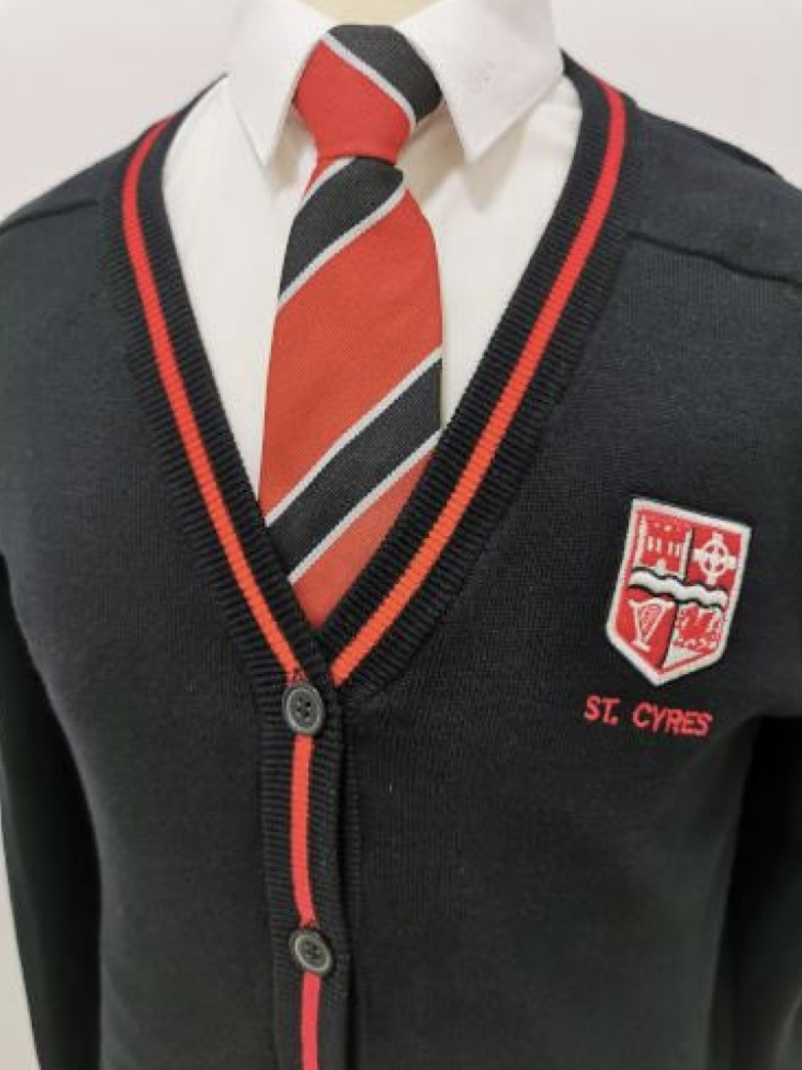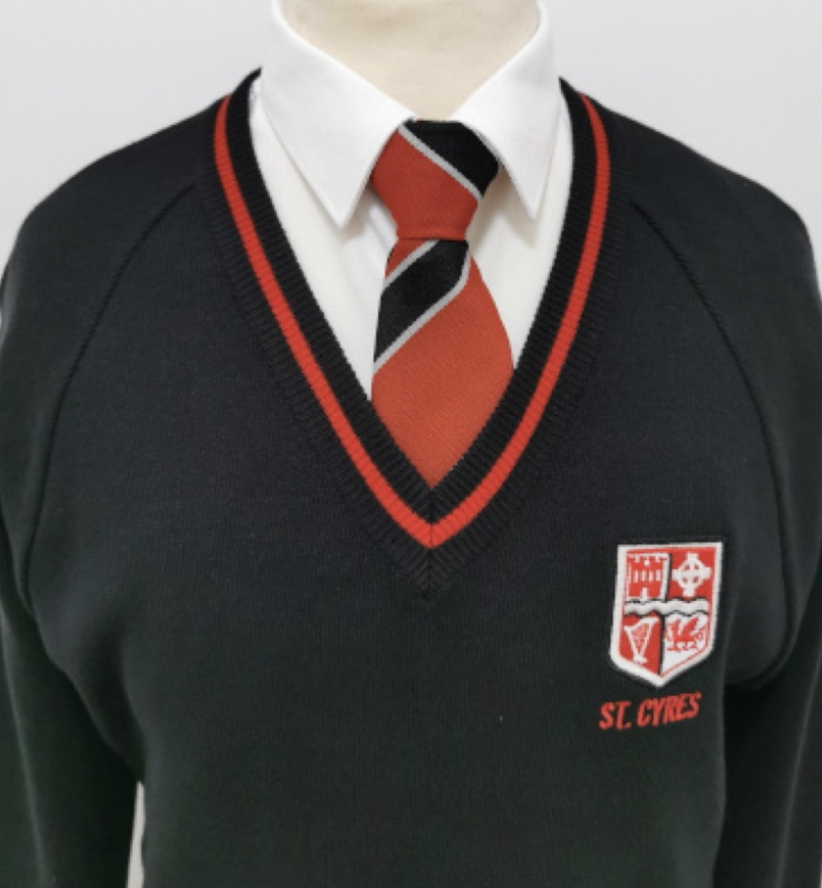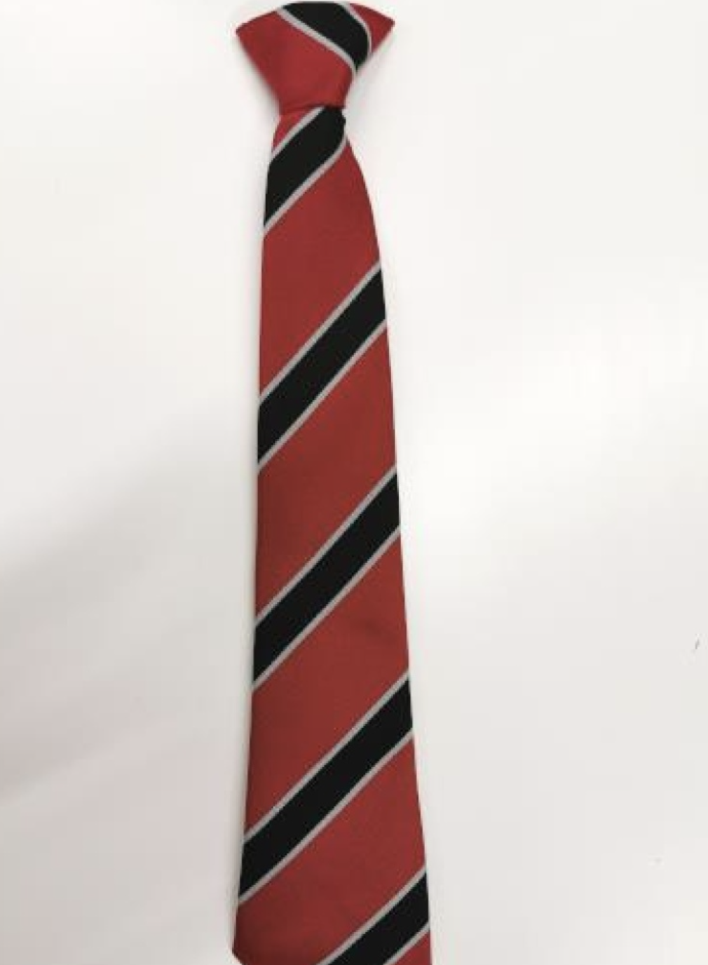

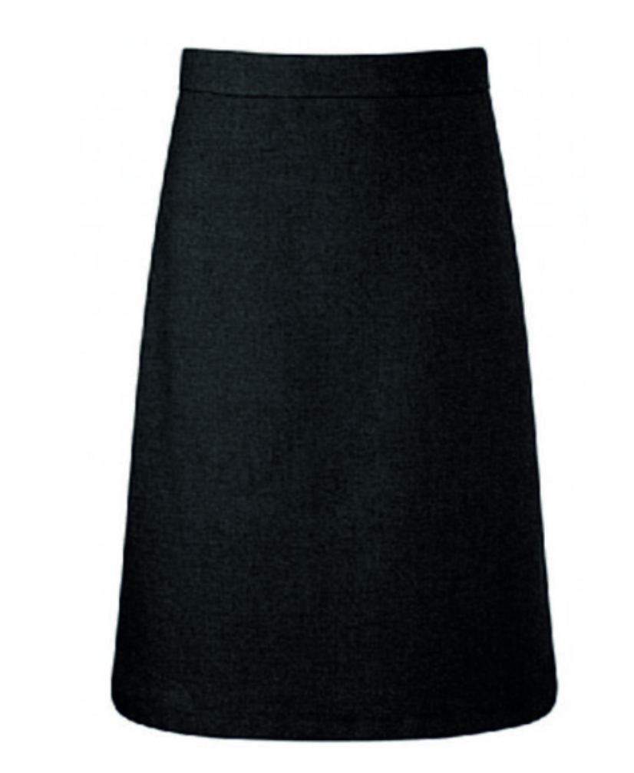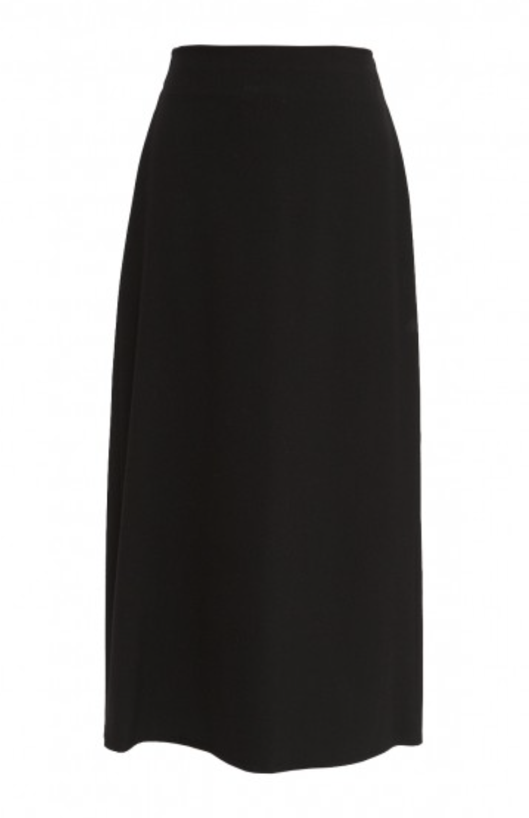


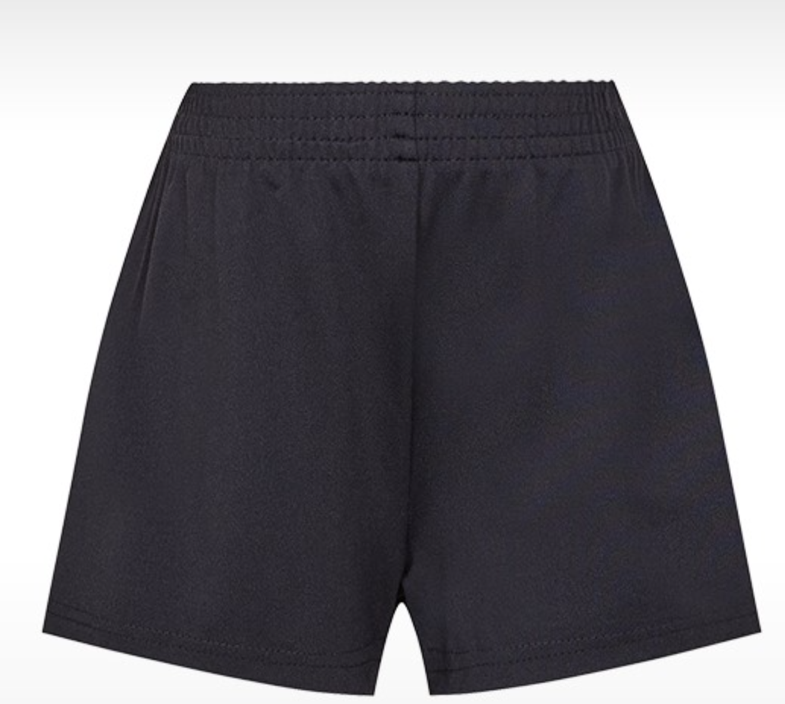

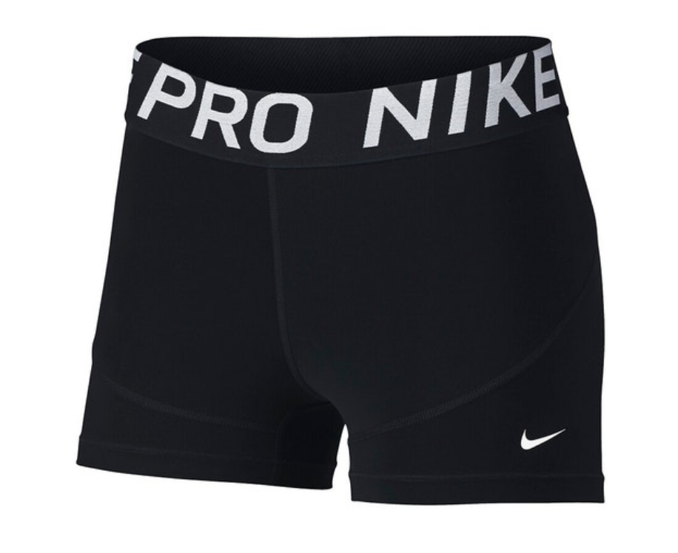

Socks/Tights – black/grey long/short socks. Thick black plain tights only. Shoes - Plain black, low heeled, leather or leather look shoes.
No boots, trainers, logos, canvas, decorative additions allowed.

Top Coat - Plain black.
No hoodies, logos, motifs, patterns, denim, leather/leather look or velvet.

School Bag - Plain black or any other dark colour.

PE Kit
• St Cyres logo black, red and white polo shirt. (NEW Design*)
• St Cyres logo black and red hoodie. (NEW Design*)
• Plain black sports leggings, or generic black shorts.
• Additionally plain black tracksuit bottoms.
• Plain black sport socks.
• Trainers (and rugby/football boots for Boys’ PE).
• Strongly advisable that pupils wear shin pads during Football, Rugby and Hockey.

*Please note that the new design PE tops will be available to purchase from uniform providers by the end of the summer term.

All kit to be clean and brought to every lesson. It is vital that all pupils adhere to the strict kit rules as levels of safety and hygiene are of the utmost importance in the St Cyres PE Department. If pupils have an injury or a reason they cannot participate in PE, they must supply a note from home.

However, pupils must still bring their PE kit and change into it as they will be given an alternative role, such as a coach or referee. The only reason a student would be excused from changing is if they have a doctor’s note.

Any issue regarding the suitability of PE kit is at the discretion of their PE teacher.

School Shoes
All pupils should wear formal, plain black school shoes. Pupils should not wear shoes that have coloured or logos, backless sandals, branded trainers or ‘leisure’ shoes.
The following photographs illustrate examples of acceptable footwear and all to be worn with black or grey socks.
Acceptable styles – Slip on, lace up, Velcro fastening.

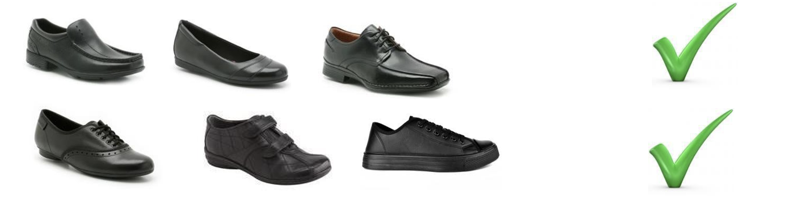

The following and similar styles of footwear do not meet the school’s uniform policy:
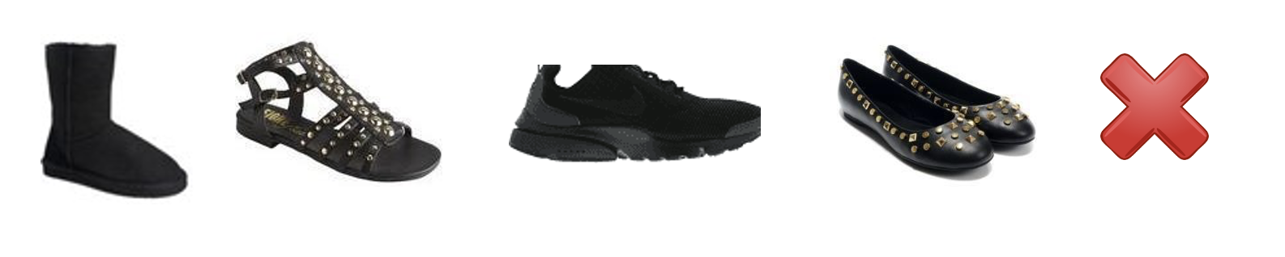
• Boots, flip-flops, high heels, platforms full or part canvas shoes are not allowed.
• Children coming to school during the winter months can wear boots but must bring with them black school shoes to change into.

St Cyres School equipment list

Pens (blue or black ink)
Pencils
30cm Ruler
Eraser
Sharpener
Highlighter
Colour pencils
Calculator*
Maths stationery set (including compass, protractor etc.)
Glue sticks
Pencil case

*Please note: It would be useful for Year 7 to purchase a specific scientific calculator so that they become familiar with the mathematical functions early on. The recommended scientific calculator for all pupils in St Cyres School is the Casio FX83GT classwiz (see photo). This can be purchased from most supermarkets, WH Smiths etc.

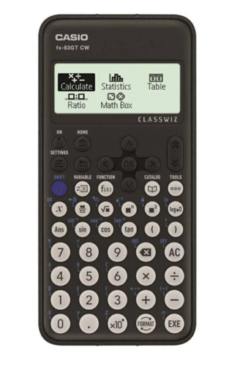

ST CYRES SCHOOL RULES APPLY FOR COMMON SENSE, SAFETY AND SECURITY REASONS. REFER TO THE PROSPECTUS ON THE SCHOOL WEBSITE FOR FURTHER DETAILS.

AROUND THE SCHOOL

• All are pupils to wear the correct uniform.
• Walk not run in corridors and keep to the left.
• Pupils are not allowed to leave the school site without permission.
• Food to be eaten in the canteen only.
• Be polite and courteous to staff, each other and visitors.
• Damage to property, accidental or otherwise, must be reported to a member of staff. Pupils may be asked to contribute towards the repair of certain damage.

IN THE CLASSROOM

• Pupils should arrive at school at least five minutes before the first lesson.
• Pupils to be punctual to all lessons.
• Bring iPad to every lesson. Pupils must not graffiti on the iPad cover. Damage/loss to be reported to the Year Office.
• Work hard and allow others to do the same.
• Follow instructions.
• Treat everyone with respect.

PERSONAL ITEMS

• Pupils’ personal items such as mobile phones and similar electronic items are not covered under the school’s insurance for loss, theft or damage and staff will not investigate any such incidents.
• Smoking/vaping/carrying cigarettes, e-cigarettes and matches is strictly forbidden anywhere on the school site.
• Gum is not permitted.
• No dangerous implements or substances are to be carried.
• Where expensive musical instruments have to be brought on site, these must be taken to the Music Faculty for safe-keeping.
• Pupils are requested not to bring anything valuable or large sums of cash into school.

TRAVEL AND ROAD SAFETY

• Crossing the busy Redlands Road should only be attempted at the road crossings. Pupils are to use the pupil paths and arrive via the pupil entrance. Parents are not to drop their children off on the main school site.
• Cycling on school premises is not allowed and cycles must be locked in the appropriate places.
• Pupils are expected to behave positively at all times as they represent the school. This particularly refers to travelling to and from school, especially on public transport/school buses.

